Shape Hierarchy

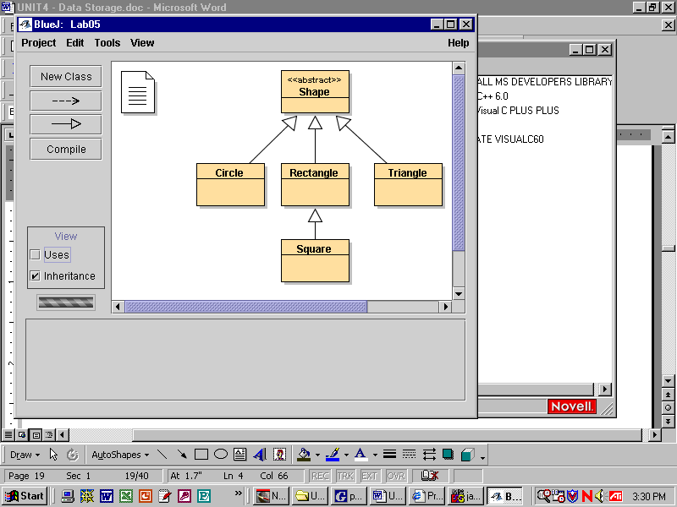

public abstract class Shape
{
public abstract double findArea();
}

public class Circle
extends Shape

Field Summary
private double | myRadius

Constructor Summary
Circle(double x)
Constructs a circle with initial radius specified by x.

Method Summary
double | findArea()  Calculates and returns the circle's area.
double | findCircumference()  Calculates and returns the circle's circumference.
double | getRadius()  Returns the circle's radius
void | setRadius(double x)  Sets the radius to the input number.

Lab06 -- Shapes

Driver06 instantiates four objects and tests their instance methods

Circle c = new Circle(75);
System.out.println("Circle");
System.out.println("------");
System.out.println("Radius: " + c.getRadius());
System.out.println("Area: " + c.findArea());
System.out.println("Circumference: " + c.findCircumference());

Your job is to make the instance methods work -- perhaps a look at the Bug class from Unit 2, Lab05, will help you with the keywords and syntax for constructors, the get and set methods, and the return methods.

Output goes to a text file called "output.txt".

System.setOut(new PrintStream(new FileOutputStream("output.txt”)));

Open "output.txt" after your program is finished executing

Lab06 – Javadoc

javadoc style -- each class and method preceded by a helpful description

each javadoc comment begins with /** and ends with */

some descriptions include an @ tag -- @author, @version, @param, and @return

produce a well-commented Rectangle.html API -- look at the Bug class from Unit 2, Lab05
/*****************************************************************
* A Circle is a Shape that maintains information about its radius. A
* Circle knows how to return its radius, set its radius, calculate and
* return its area, and calculate and return its circumference.
* @author Torbert, e-mail: mr@torbert.com, website: www.mr.torbert.com
* @version 7.14.2003
****************************************************************/
public class Circle extends Shape
{
private double myRadius;
/***************************************************************
* Constructs a circle with initial radius specified by x.
* @param x initial radius
****************************************************************/
public Circle(double x)
{
myRadius = x;
}
/****************************************************************
* Returns the circle's radius
* @return radius
****************************************************************/
public double getRadius()
{
return myRadius;
}
/****************************************************************
* Sets the radius to the input number.
* @param x assigns x to myRadius
****************************************************************/
public void setRadius(double x)
{
myRadius = x;
}

